
9
SPEAR

Surveying and Planning through Electronic Applications and Referrals



SPEAR Release Notes

Release 5.19

The following functional changes to SPEAR have been included in Release 5.19:
 | Users Impacted | Feature | Description
 | Applicant contacts, Land Use Victoria | Updates to reflect the Surveying (Cadastral Surveys) Regulations 2025  - CR 5959 | Digital signature watermarks and signing text in SPEAR have been updated to reflect the Surveying (Cadastral Survey) Regulations 2025.  The updated watermarks will apply to documents digitally signed from this release onwards.
 | Responsible authorities, Land Use Victoria | Record theme and gender information against new road names  - CR 5900 | Responsible authorities will now be asked to provide more information about each new road name created in a certification or joint planning permit and certification application.  A new action ‘Add New Road Information’ will appear once the street addresses have been added, allowing responsible authorities to provide the following details for each unique road created in the plan:  - Road name theme  - Whether the road is named after a person and, if so, the gender of the person  - History / Origin of the road name  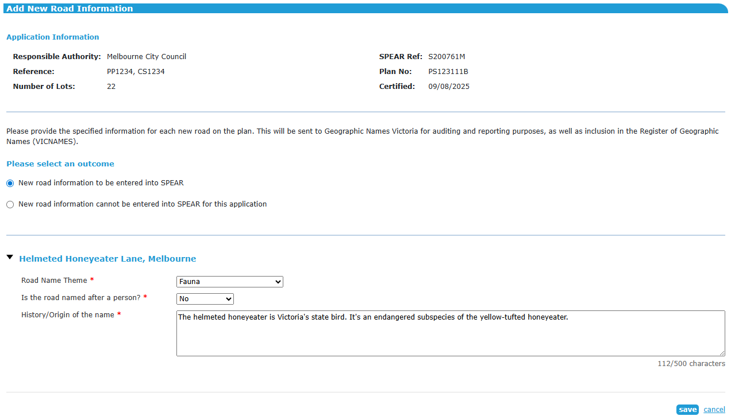  New road information will be sent to Geographic Names Victoria for auditing and reporting purposes, as well as inclusion in the Register of Geographic Names (VICNAMES).
 | All users | Requisition workflow and notification enhancements  - CR 5440 | - The ‘request only’ requisition functionality is now available in the following application types:  A ‘request only’ requisition made by Land Use Victoria (LUV) will not place a mandatory action on the applicant contact to respond in SPEAR. If required, applicant contacts can provide a response using ‘Other Document Type’ or any other relevant action available.  - SPEAR has been enhanced to send several new notification emails, including:  - Notifying LUV when a responsible authority rejects a re-certification following a requisition  - Notifying the lodging party when their request to withdraw an application at LUV has been actioned  - Notifying relevant users when an application has been rejected by LUV  - Sending a copy of the purchased plan numbers to the requesting user  Note: Purchased plan numbers will also continue to be sent to the organisation’s email address for SPEAR notifications.
  - Transfer of Land Act | - Transport Survey Plan
  - Boundary Plan | - Other
  - Local Government Act | - Certification / Planning Permit and Certification (existing functionality)

